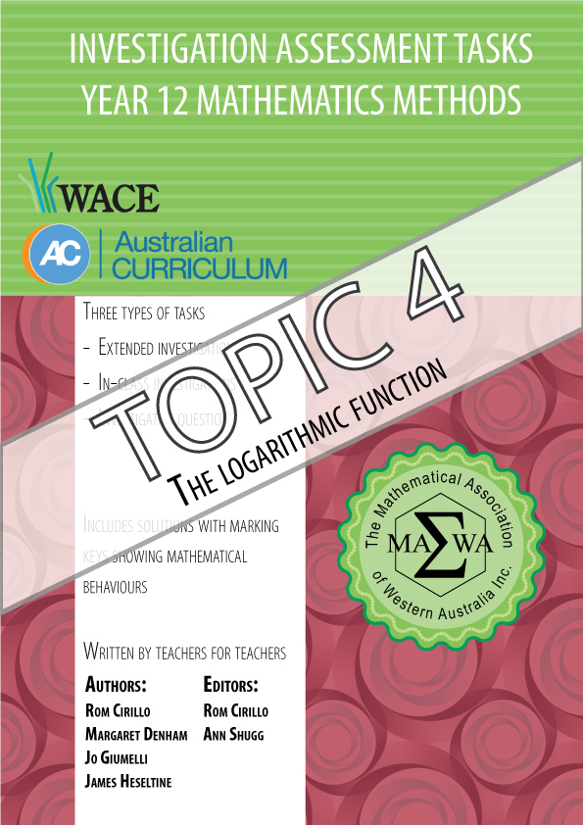

|  |
| --- |
| For each topic three types of tasks are included: |
| Extended investigation – an investigation which could be done in the student’s own time followed by an in-class validation. Solutions are provided where practicable for the preparation activity/investigation. For the in-class validation, there are solutions and marking keys which identify the mathematical behaviours that students may exhibit. |
| In-class investigation – an investigation for which no prior preparation is required. Solutions and marking keys are provided. |
| Investigative questions – a series of short questions which test the student’s ability to apply their learning, to justify their conclusions, to investigate and to generalise, or to solve problems. Such questions could be included in a response or examination assessment. Solutions and marking key are provided. |

Screen shot have been produced using the CASIO ClassPad II emulator or the

ti-nspire CAS emulator.

Most graphs and diagrams have been produced using efofex software.

© The investigations and solutions in this publication are for the sole use of staff and students of the purchasing school. It is a breach of copyright to distribute them in whole or part in any form now or in the future to any other school, company or person.

**Contents:**

**MATHEMATICS METHODS: Year 12**

**3.1 Further differentiation and applications**

Task 1: Extended investigation: The second derivative

Task 2: In-class investigation: Taylor series

Task 3: Investigative questions

**3.2 Integrals**

Task 4: Extended investigation: Area between functions

Task 5: In-class investigation: Areas between graphs and the *x*-axis

Task 6: Investigative questions

**3.3 Discrete random variables**

Task7: Extended investigation: Distribution of sample means

Task 8: In-class investigation: Binomial distribution

Task 9: Investigative questions

**4.1 The logarithmic function**

Task10: Extended investigation: Logarithms

Task 11: In-class investigation: The logarithm function

Task 12: Investigative questions

**4.2 Continuous random variables and the normal distribution**

Task13: Extended investigation: The Normal distribution curve

Task 14: In-class investigation: Continuous distribution curves

Task 15: Investigative questions

**4.3 Interval estimates for proportions**

Task16: Extended investigation: TBA

Task 17: In-class investigation: TBA

Task 18: Investigative questions

This package only contains the investigations associated with **topic 4.1: The logarithmic function**

If your school has purchased the complete set of 18 investigations, you will be informed when the rest are ready for delivery/download.

# TASK 10: THE USEFULNESS OF LOGARITHMS

**Extended Investigation**

**Unit 4**

**Topic 4.1: The logarithmic function**

**Course-related information**

The concepts and skills included in this investigation relate to the following dot points within the WA Mathematics Methods syllabus.

4.1.3examine the inverse relationship between logarithms and exponentials:

 is equivalent to 



4.1.4 interpret and use logarithmic scales

4.1.8 identify contexts suitable for modelling by logarithmic functions and use them

to solve practical problems

The ability to choose and use appropriate technology to enhance and extend concept development are also incorporated within some of the items.

**Background information**

Students need to be familiar with the properties of logarithms and curve fitting on their calculator.

**Task conditions**

Students have a take home section of the investigation. Students then have an in-class assessment on the contents of the investigation.

Students should not be permitted to take their investigative material into the in-class assessment. Students need to bring their graphical/CAS calculator to the assessment.

# The usefulness of logarithms

# Extended Investigation Part 1: Preparation activity

The following chart shows the loudness levels, some of which can damage the human ear.

|  |  |  |
| --- | --- | --- |
| Chart of sound intensity levels (loudness)for environmental noise | | |
|  | Weakest sound heard | 0 dB |
|  | Rustling leaves | 10 dB |
|  | A whisper in library at 2 m | 30 dB |
|  | Converation at home | 50 dB |
|  | Conversation in restaurant | 60 dB |
|  | Passenger car at 80 kph at 6 m | 70 dB |
|  | Vacuum cleaner at 1m | 70 dB |
|  | Freeway at 20 m | 73 dB |
|  | Telephone dial tone | 80 dB |
| At 90 - 95 dB sustained exposure may sustain hearing loss | Car wash at 6 m | 90 dB |
| Train whistle at 150 m | 90 dB |
|  | Hand drill | 98 dB |
|  | Lawn mower at 1M | 105 dB |
|  | Motorbike | 100 dB |
|  | Jet take off at 300 m | 100 dB |
|  | Sand blasting | 115 dB |
| Threshold of discomfort | Thunderclap | 120 dB |
|  | Chain saw | 120 dB |
|  | Oxygen torch | 120 dB |
|  | Loud rock concert | 115 dB |
| Pain threshold 130 dB | Pneumatic riveter | 125 dB |
|  | Aircraft carrier deck | 140 dB |
| Eardrum rupture | Jet take off at 25 m | 150 dB |

The reference level of the intensity of sound, *I*that all others are compared to is

10 -12 watts/m 2. It was chosen because it is the weakest intensity of sound that can be detected by the human ear.

Intensity, *I*  so *I* is measured inwatts/m 2.

*I* = 10 -12 watts/m 2.

The most intense sound that is not painful to humans is roughly10 watts/m2.

Since the human pain threshold at 10 watts/m 2 is 10,000,000,000,000 times greater than the reference level, it makes sense to use a logarithmic scale to discuss

the intensity of sound, *I.*

The sound intensity level, *L*, is a logarithmic measure given as

*L* = 10 log $\left( \frac{I}{I_{0}}\right)$ and is measured in decibels (dB).

The lowest sound heard by man is



The loudest sound heard without pain (ie. the pain threshold) is 10 watts/m2.



**Question 1**

Prove that the pain threshold is 1013 times more intense than the lowest sound heard by man.

**Question 2**

(a) What is the sound intensity level that corresponds to a sound that has an intensity of 10-2 watts/m2?

(b) What sound could this be from the table?

**Question 3**

(a) How many times more intense is the sound of a loud rock concert than the sound of a conversation at home?

Hint : Find 

(b)How many times more intense is the sound of a conversation in a restaurant than the sound of a conversation at home?

**Question 4**

Determine the intensity in watts/m 2 of the following sounds

(a) (i) a chain saw

(ii) a vacuum cleaner at 1m

(iii) rustling leaves

(iv) a telephone dial tone

(v) a hand drill

(vi) an aircraft carrier deck

(vii) the ticking of a watch with a sound intensity level of 20 dB

(b) Explain the reason for using sound intensity levels in decibels rather than intensity in watts/m 2*.*

**Question 5**

Use the semi – logarithm graph paper (one axis has a logarithmic scale) to plot some of the intensities of the sounds in **Question 4** against their sound intensity levels and comment on the shape of the graph.

What is the advantage of using this graph paper for the data from Question 4?

10

1

0.10000

Intensity of

sound ( *I* )

0.01000

0.00100

0.00010

0.00001

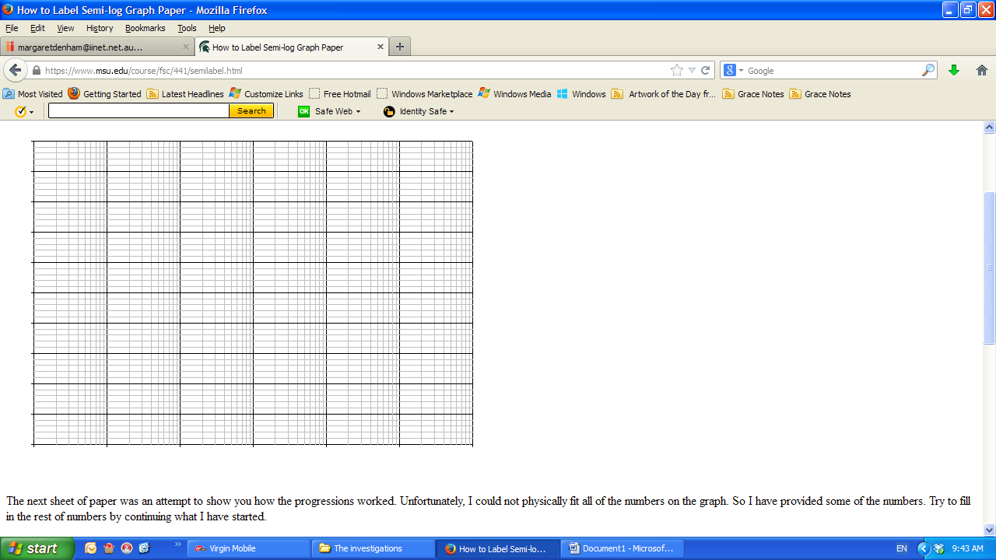

50 60 70 80 90 100 110 120 130

Sound intensity level (*L*) Decibels

Semi-logarithm graphs are useful when graphing data that increases exponentially.

For example, a population of rabbits that is doubling every year.

|  |  |  |  |  |  |  |  |  |  |  |
| --- | --- | --- | --- | --- | --- | --- | --- | --- | --- | --- |
| Year | Population | |  | | --- | |  | |  |  |  |  |  |  |  |
| 1 | 1 |  | Population of rabbits |  |  |  |  |  |  |
| 2 | 2 | Population |  |  |  |  |  |  |  |
| 3 | 4 |  |  |  |  |  |  |  |  |
| 4 | 8 |  |  |  |  |  |  |  |  |
| 5 | 16 |  |  |  |  |  |  |  |  |
| 6 | 32 |  |  |  |  |  |  |  |  |
| 7 | 64 |  |  |  |  |  |  |  |  |
| 8 | 128 |  |  |  |  |  |  |  |  |
| 9 | 256 |  |  |  |  |  |  |  |  |
| 10 | 512 |  |  |  |  |  |  |  |  |
| 11 | 1024 |  |  |  |  |  |  |  |  |
| 12 | 2048 |  |  |  |  | Years |  |  |  |
| 13 | 4096 |  |  |  |  |  |  |  |  |
| 14 | 8192 |  |  |  |  |  |  |  |  |
| 15 | 16384 |  |  |  |  |  |  |  |  |

log10(Population)

|  |  |  |  |  |  |  |  |  |  |  |
| --- | --- | --- | --- | --- | --- | --- | --- | --- | --- | --- |
| Year | log10(Population) | |  | | --- | |  | |  |  |  |  |  |  |  |
| 1 | 0.30103 |  |  |  |  |  |  |  |  |
| 2 | 0.60206 |  |  |  |  |  |  |  |  |
| 3 | 0.90309 |  |  |  |  |  |  |  |  |
| 4 | 1.20412 |  |  |  |  |  |  |  |  |
| 5 | 1.50515 |  |  |  |  |  |  |  |  |
| 6 | 1.80618 |  |  |  |  |  |  |  |  |
| 7 | 2.10721 |  |  |  |  |  |  |  |  |
| 8 | 2.40824 |  |  |  |  |  | Years |  |  |
| 9 | 2.70927 |  |  |  |  |  |  |  |  |
| 10 | 3.0103 |  |  |  |  |  |  |  |  |
| 11 | 3.31133 |  |  |  |  |  |  |  |  |
| 12 | 3.61236 |  |  |  |  |  |  |  |  |
| 13 | 3.91339 |  |  |  |  |  |  |  |  |
| 14 | 4.21442 |  |  |  |  |  |  |  |  |
| 15 | 4.51545 |  |  |  |  |  |  |  |  |

**If the function is exponential, then using semi-logarithm paper makes the graph linear.**

**Question 6**

Prove that if the function is exponential, say y = A(b)t  then the function logc(y) graphed against t is linear.

# The dangers of being a musician

**Extended investigation Part 2: In-class validation**

**Total marks**: **31**

Prolonged exposure to loud music can result in hearing loss.

The two major characteristics of sound are intensity and frequency (pitch).

We are only considering intensity of sound, *I*, which is measured inwatts/m 2.

The sound intensity level , *L,*  is a logarithmic measure given as

*L* = 10 log $\left( \frac{I}{I_{0}}\right)$ and measured in decibels (dB)

*I* = 10 -12 watts/m 2.

The reference intensity of sound, *I*, that all other intensities are compared to is

10-12 watts/m2 because this is the weakest intensity of sound that can be detected by the human ear.

**Question 1 (2 marks)**

Determine the sound intensity level of normal piano practice when the intensity of the sound of the music is 10- 5 watts/m 2.

**Question 2 (7 marks)**

The maximum sound intensity level of an orchestra playing is 110 dB.

(a) The sound intensity level of a live performance of a rock band can reach

135 dB**.** Howmany times more intense is the sound of the music of a live rock band than the music of an orchestra? (4)

(b) The sound intensity level of chamber music in a small auditorium is around

90 dB. How many times less intense is the sound of the chamber music than the music of an orchestra? (3)

**Question 3 (2 marks)**

(a) Given the range of the sound intensity levels, *L*, of the following musical instruments, which two instruments have the potential to do the most damage to the human ear? (1)

|  |  |
| --- | --- |
|  | *L* (dB) |
| Violin | 84-102 |
| Cello | 82-93 |
| Oboe | 90-94 |
| Flute | 85-110 |
| Piccolo | 95-112 |
| Clarinet | 92-102 |
| French horn | 90-105 |
| Trombone | 85-114 |
| Timpani and bass drum rolls | 107 |

(b) What other factors need to be considered? (1)

**Question 4 (12 marks)**

The table below shows the average sound intensity levels (*L*) and the intensity of the sound (*I* ) of some instruments of a symphony orchestra. The ratios $\left( \frac{I}{I_{0}}\right)$ are also given for each instrument.

(a) Determine the missing values (i) – (iv) (2)

|  |  |  |  |
| --- | --- | --- | --- |
| musical instrument | average sound intensity level, *L*  *(* dB *)* | $\left( \frac{I}{I_{0}}\right)$ | intensity of sound, *I*  *(* watts/m 2 ) |
| Violin | 93 | 1 995 262 315 | 0.0019953 |
| Cello | 87.5 | (i) | (iii) |
| Oboe | 92 | 1 584 893 192 | 0.0015849 |
| Flute | 97.5 | 5 623 413 252 | 0.0056234 |
| Piccolo | 103.5 | (ii) | (iv) |
| Trombone | 99.5 | 8 912 509 301 | 0.0089125 |
| Timpani and  bass drum rolls | 107 | 50 118 723 360 | 0.0501187 |

(b) Plot the intensity of sound (*I* watts/m 2 )against the average sound intensity level

(*L* dB) for any four of the musical instruments listed in the table above. (3)

0.1000

Intensity

of sound,

*I*

0.0100

0.0010

0.0001

0.0001



85 90 95 100 105 110

Average sound intensity level, *L*

**Question 4 (continued**

(c) Identify the relationship between the points you have plotted. (1)

(d) Using the graph or otherwise, determine the average sound intensity level of the sound from a musical instrument that has an intensity of sound of 0.1 watts/m 2.

(1)

(e) Explain why a semi – logarithm grid was useful for the data graphed. (1)

(f) (i) What shape would the *L* – *I* graph take? Explain your decision. (2)

(ii) Using your calculator or any other method, determine the equation that best fits the *L* – *I* data. (2)

**Noise exposure**

It is said that an increase of 3 decibels in sound intensity level will double the intensity of the sound.

**Question 5 (8 marks)**

(a) By finding an expression for *I* at a sound intensity level of 80 dB and *I* at a sound intensity level of 83 dB, show why increasing the sound intensity level by 3 dBdoubles the value of *I.* (4)

(b) Show how this is the case at any sound intensity level. (4)

**End of questions**

**The usefulness of logarithms**

**Extended investigation Part 1:** **Preparation activity**

**Solutions**

**Question 1**

|  |
| --- |
| 0 dB has *I = I0* = *10 -12 watts/m 2*.  130 dB has *I* = *10 watts/m2*    i.e. the pain threshold is 10 000 000 000 000 times more intense than the lowest sound heard by man. |

**Question 2**

|  |
| --- |
| (a)    (b) The sound could be a motorbike or a jet taking off 300 m away. |

**Question 3(a)**

|  |
| --- |
| *I0* = *10 -12 watts/m 2*.  Rock concert *L* = 115 dB Conversation at home *L* = 50 dB      So the rock concert is 3 million times more intense than a conversation at home. |

**Question 3(a) (cont’d)**

|  |
| --- |
| **Alternative method:**      etc |

**Question 3(b)**

|  |
| --- |
| So the conversation in a restaurant is 10 times more intense than a conversation at home. |

**Question 4(a)**

|  |
| --- |
| (i) a chain saw at 120 db    (ii) a vacuum cleaner at 1mat 70 dB    (iii) rustling leaves at 10 dB    (iv) a telephone dial tone at 80 dB    (v) a hand drill at 98 dB    (vi) an aircraft carrier deck at 140 dB    (vii) the ticking of a watch with a decibel reading of 20 dB |

**Question 4(b)**

|  |
| --- |
| Decibels are within a much more manageable range, for example for human hearing 0 to about 130. Humans can distinguish and associate sounds within such a range. |

**Question 5**

|  |
| --- |
| Semi-logarithm paper squashes the y axis into a manageable scale so it is possible to use all parts of the number range on the graph. |

**Question 6**

|  |
| --- |
| This is of the form    where is constant, and the constant gradient. |

**The usefulness of logarithms**

**Extended investigation Part 2: In-class validation**

**Solutions and marking key**

**Question 1**

|  |  |
| --- | --- |
| Solution | |
| *L* = 10 log $\left( \frac{{10}^{-5}}{I_{0}}\right)$ *L* = 10 log $\left( \frac{{10}^{-5}}{{10}^{-12}}\right)$ = 10 log (${10}^{7}$)  = 70 log10 =70  Sound intensity level of normal piano practice is 70 decibels | |
| Mathematical behaviours | Marks |
| * substitutes correctly into formula * determines correct value for *L* | 1  1 |

**Question 2(a)**

|  |  |
| --- | --- |
| Solution | |
| Live rock band 135 dB Orchestra playing at 110 dB      So the live rock band is 316 times more intense than a orchestra. | |
| Mathematical behaviours | Marks |
| * determines intensity of sound of orchestra * determines intensity of sound of a rock band * makes the comparison * states conclusion | 1  1  1  1 |

**Question 2(b)**

|  |  |
| --- | --- |
| Solution | |
| Orchestra playing at 110 dB Chamber music playing at 90 dB      Chamber music has the intensity of 1% of the orchestra. | |
| Mathematical behaviours | Marks |
| * determines intensity of chamber music * makes the comparison * states conclusion | 1  1  1 |

**Question 3**

|  |  |
| --- | --- |
| Solution | |
| (a) Trombone and piccolo  (b) Other factors that need to be considered is the duration of play of each  instrument and the sounds emitted by the surrounding players. | |
| Mathematical behaviours | Marks |
| * (a) identifies the two instruments * (b) anything sensible | 1  1 |

**Question 4(a)**

|  |  |
| --- | --- |
| Solution | |
| |  |  |  |  | | --- | --- | --- | --- | |  | Average sound intensity level, *L* | $$\left( \frac{I}{I_{0}}\right)$$ | *I* | | Violin | 93 | 1 995 262 315 | 0.0019953 | | | Cello | 87.5 | **562 341 325** | **0.0005623** | | | Oboe | 92 | 1 584 893 192 | 0.0015849 | | | Flute | 97.5 | 5 623 413 252 | 0.0056234 | | | Piccolo | 103.5 | **22 387211 390** | **0.0223872** | | | Trombone | 99.5 | 8 912 509 301 | 0.0089125 | | | Timpani & bass drum | 107 | 50 118 723 360 | 0.0501187 | | | |
| Mathematical behaviours | Marks |
| * calculates 2 missing values correctly * calculates another 2 missing values correctly | 1  1 |

**Question 4(b)**

|  |  |
| --- | --- |
| Solution | |
| (b)  0.1000  Intensity *I*  0.0100  0.0010  0.0001    85 90 95 100 105 110  Average sound intensity level,  *L* | |
| Mathematical behaviours | Marks |
| * plots 2 points correctly * plots 3rd point correctly * plots 4th point correctly | 1  1  1 |

**Question 4(c)**

|  |  |
| --- | --- |
| Solution | |
| The points are almost collinear which indicates that when semi-logarithm graph paper is used the graph is linear | |
| Mathematical behaviours | Marks |
| * identifies linear relationship | 1 |

**Question 4(d)**

|  |  |
| --- | --- |
| Solution | |
| From graph or | |
| Mathematical behaviours | Marks |
| * determines correct value or approximate value from graph | 1 |

**Question 4(e)**

|  |  |
| --- | --- |
| Solution | |
| A semi-logarithm graph is useful as the numbers have a large range even though the numbers are small. | |
| Mathematical behaviours | Marks |
| * gives a suitable explanation | 1 |

**Question 4(f)**

|  |  |
| --- | --- |
| Solution | |
| (i) The *L* – *I* graph would take the form of an exponential graph as below      which is exponential.  (ii) Using calculator    Therefore  *y* = (9.522×10-13)×e0.2289x  i.e. *I* = (9.522×10-13)×e0.2289*L* | |
| Mathematical behaviours | Marks |
| * (i) states exponential graph. * justifies choice of exponential function either using the calculator or using the rule * (ii) determines the equation | 1  1  2 |

**Question 5(a)**

|  |  |
| --- | --- |
| Solution | |
| *L* = 80 dB, *I* = ?  *L* = 83 dB, *I* = ?    100.3 × *l80* = *l83*  But 100.3 = 2 (log102 = 0.3)  Therefore the intensity of the sound at 83 dBs is twice that at 80dB. | |
| Mathematical behaviours | Marks |
| * calculates the intensity for sound intensity level of 80 dB * calculates the intensity for sound intensity level of 83 dB * obtains one as a multiple of the other * determine that the multiple is 2 | 1  1  1  1 |

**Question 5(b)**

|  |  |
| --- | --- |
| Solution | |
| At x dB, *I* = ? At x+3 dB, *I* = ?      Therefore the rule works at any level x of dBs. | |
| Mathematical behaviours | Marks |
| * calculates the intensity for x dBs * calculates the intensity for x+3 dBs * obtains one as a multiple of the other * determine that the multiple is 2 for any value of x | 1  1  1  1 |

**TASK 11: THE LOGARITHMIC FUNCTION**

**In-class investigation**

**Unit 4**

**Topic 4.1: The logarithmic function**

**Course-related information**

The concepts and skills included in this investigation relate to the following dot points within the WA Mathematics Methods syllabus.

4.1.1define logarithms as indices: is equivalent to i.e.

4.1.2establish and use the algebraic properties of logarithms

4.1.3examine the inverse relationship between logarithms and exponentials: $y=a^{x}$ is

equivalent to $x=\log_{a}{y}$

4.1.5solve equations involving indices using logarithms

4.1.6identify the qualitative features of the graph of $y=\log_{a}{x}$ ($a>1)$, including

asymptotes, and of its translations $y=\log_{a}{x}+b$ and ${y=log}_{a}{(x-c)}$

4.1.7solve simple equations involving logarithmic functions algebraically and graphically

* + 1. define the natural logarithm $\ln{x}=\log_{e}{x}$
    2. examine and use the inverse relationship of the functions $y=e^{x}$ and $y=\ln{x}$

4.1.13determine derivatives of the form $\frac{d}{dx}\left(\ln{f(x})\right)$ and integrals of the form $\int{\frac{f^{'}\left(x\right)}{f\left(x\right)}}dx$, for $f (x)>0$

The ability to choose and use appropriate technology to enhance and extend concept development are also incorporated within some of the items.

**Background information**

Students should have an understanding of the above points before they start this investigation.

**Task conditions**

The task should be done under test conditions in class. Use of a graphical/CAS calculator is permitted.

**The logarithmic function**

**In-class investigation Total marks: 50**

**Question 1** **(4 marks)**

Solve for *x*

(a)  (2)

(b)  (2)

**Question 2 (10 marks)**

True or false? Justify your decision.

(a)  (2)

(b)  for *x* ≠0 (2)

(c)  (2)

(d)  (2)

(e) is defined for *x* > -1 (2)

**Question 3** **(9 marks)**

(a) (i) Prove that ln( $\frac{xy}{z})$ = ln(*x*) + ln(*y)* – ln(*z*) (4)

(ii) Determine the slope of the tangent to the function, *y* = ln ($\frac{ e^{x}(x^{2}+5)}{x^{3}- 4x} )$,

at any point (*x,y*), using the relationship proved in part (i).

(5)

**Question 4** **(15 marks)**

(a) (i) Sketch the graph of each of the functions $y=\log_{2}(x+2)$ and

${y=log}_{2}\left(x\right)+2$ on the axes below. (2)

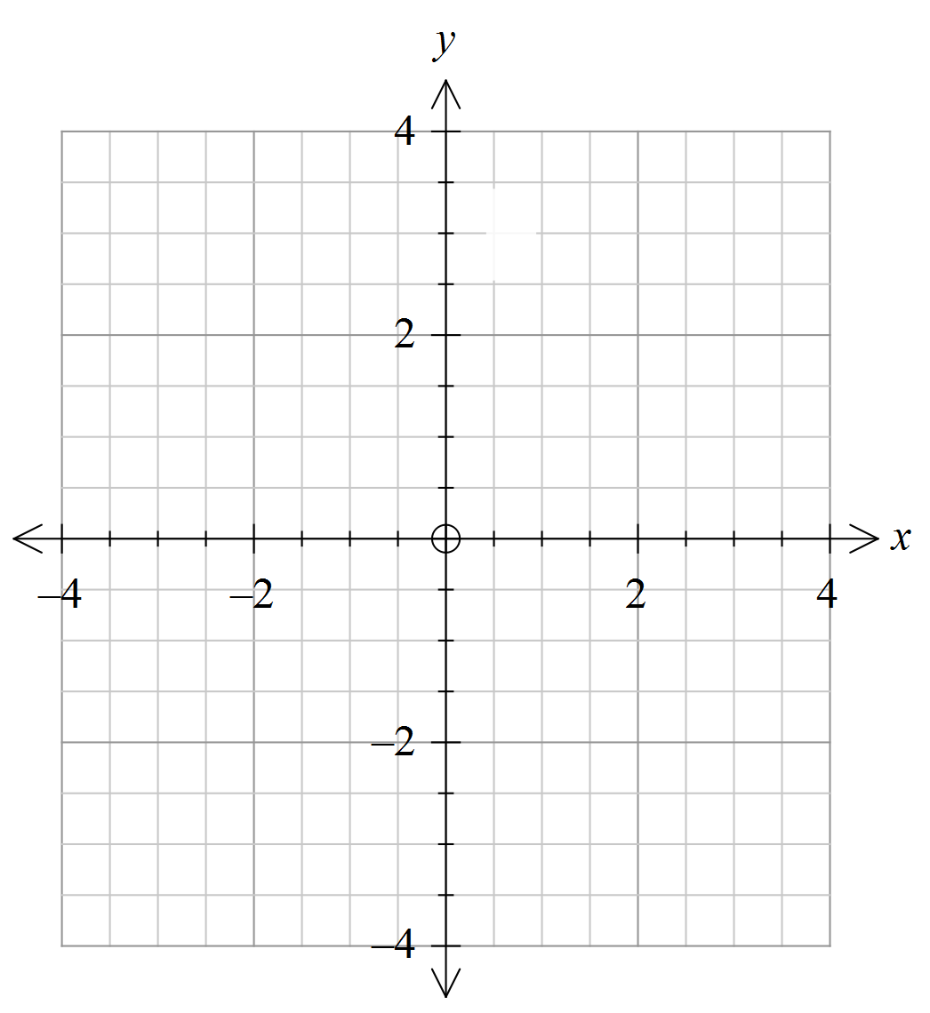

(ii) State the co-ordinates of all points of intersections of the graphs. (1)

(b) (i) State the domain, range and the equations of any asymptotes for each

function. (4)

(ii) Explain how the graph of each function is related to the graph of $y=\log_{2}\left(x\right)$

(2)

**Question 4 (continued)**

(c)

|  |  |
| --- | --- |
| (i) Complete the following to make a  true statement.  When $y=\log_{2}(x+2)$,  *x + 2* =  (1) | (ii) Complete the following to make a  true statement.  When ${y=log}_{2}\left(x\right)+2$,  *x =*  (1) |

(iii) Begin the process of determining the simultaneous solution(s) of the

equations, $y=\log_{2}(x+2)$ and ${y=log}_{2}\left(x\right)+2$ algebraically, by

forming and solving an equation in one variable, *x.* (3)

(iv) Use the solution(s) of the equation formed in part (iii) to determine the corresponding solution(s) for y. (1)

**Question 5** **(12 marks)**

(a) Sketch the graph of on the axes

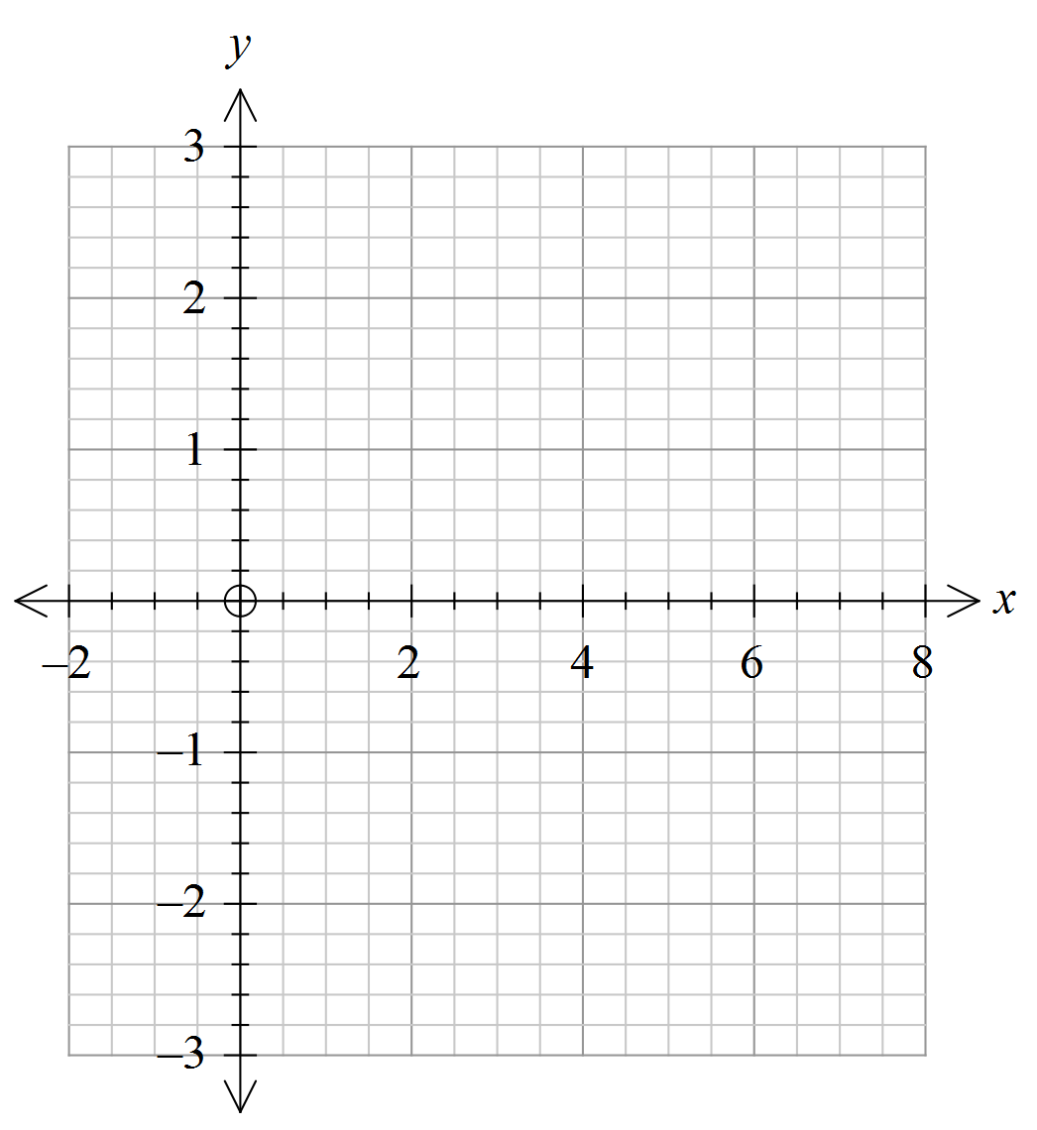 below (3)

(b) Describe the relationship between 

. (4)

[ Hint: $\log_{b}a$ = $\frac{\log_{c} a}{\log_{c} b}$]

(c) Predict the relationship between  (1)

(d) Generalise your prediction of the relationship between

 (1)

(e) Prove your relationship in (d) using the logarithmic laws. (3)

**End of questions**

**The logarithmic function**

**In-class investigation**

**Solutions and marking key**

**Question 1**

|  |  |
| --- | --- |
| Solution | |
| (i)    (ii)  4 = *x*2 | |
| Mathematical behaviours | Marks |
| * (i) identifies equivalent exponential equation * determines correct solution * (ii) identifies x > 0 * determines correct solution | 1  1  1  1 |

**Question 2**

|  |  |
| --- | --- |
| Solution | |
| (a) False  (b) False  (c) True  (d) True Let  (e) False is defined for x > -1 | |
| Mathematical behaviours | Marks |
| For each of the 5 equations (a) to (e)   * states T or F with reason | 5 × 2 |

**Question 3(a)(i)**

|  |  |
| --- | --- |
| Solution | |
| Prove ln( $\frac{xy}{z})$ = ln(*x*) + ln(*y*) – ln(*z*)  Let *x* = $e^{a}$, *y* = ${ e}^{b}$ and *z* = ${ e}^{c}$ so ln(*x*) = *a*, ln(*y*) = *b*  and ln(*z*) = *c $\frac{xy}{z}$*  = $\frac{e^{a}× e^{b}}{e^{c}}$ = $e^{a}$ $×$ $e^{b}$ $×$ $e^{-c}$ = $e^{a+b-c}$ so ln( $\frac{xy}{z})$ = *a + b – c* = ln(*x*) + ln(*y*) – ln(*z*) | |
| Mathematical behaviours | Marks |
| * determines an expression for *x, y* and *z* as a power of *e* * finds an expression for ln(*x*), ln(*y*) and ln(*z*) * substitutes in quotient to create the product as a power of *e* * uses inverse relationship to achieve the required result. | 1  1  1  1 |

**Question 3(a)(ii)**

|  |  |
| --- | --- |
| Solution | |
| *y* = ln ( $\frac{ e^{x}(x^{2}+5)}{x^{3}- 4x} )$ = ln $(e^{x})$ + ln $(x^{2}+5)$– ln $(x^{3}- 4x)$ $\frac{ dy}{dx}$ = $\frac{d}{dx}[$ ln ( $\frac{ e^{x}(x^{2}+5)}{x^{3}- 4x} )]$ = $\frac{d}{dx}$ [ ln $(e^{x})$] + $\frac{d}{dx}[$ ln $(x^{2}+5)$] – $\frac{d}{dx}$ [ ln $(x^{3}- 4x)$]  = $\frac{d}{dx}$ (*x*) + $\frac{d}{dx}[$ ln $(x^{2}+5)$] – $\frac{d}{dx}$ [ln $(x^{3}- 4x)$]  = 1 + $\frac{2x}{x^{2}+ 5}$– $\frac{{3x}^{2}-4}{x^{3}-4x}$ which is the expression for the slope of the tangent to the given function at any point (*x,y*) | |
| Mathematical behaviours | Marks |
| * acknowledges that $\frac{ dy}{dx}$ is slope of tangent to given function * applies the logarithmic rule proved in part (i) * identifies inverse functions in 1st term * determines the derivative of 2 terms * determines the derivative of another term | 1  1  1  1  1 |

**Question 4(a)**

|  |  |
| --- | --- |
| Solution | |
| (i) and (ii) | |
| Mathematical behaviours | Marks |
| * (i) graphs 1 function correctly * graphs 2nd function correctly * (ii) states correct coordinates of point of intersection | 1  1    1 |

**Question 4(b)**

|  |  |
| --- | --- |
| Solution | |
| (i)   |  |  |  |  | | --- | --- | --- | --- | | Function | Domain | Range | Asymptote | | *y* = $\log_{2 }x$ + 2 | *x* > 0 | *y∈ R* | *x = 0* | | *y* = $\log_{2}(x+2)$ | *x* > – 2 | *y∈ R* | *x = – 2* |     (ii)  The graph of *y* = $\log_{2 }x$ + 2 is the graph of *y* = $\log_{2 }x$ translated up 2 units.  The graph of *y* = $\log_{2}(x+2)$ is the graph of *y* = $\log_{2 }x$ translated to the left 2 units. | |
| Mathematical behaviours | Marks |
| * (i) states correct domain and range of 1 function * states correct domain and range of 2nd function * states correct equation of asymptote of 1 function * states correct equation of asymptote of 2nd function * (ii) describes translation of *y* = $\log_{2 }x$ correctly for 1 function * describes translation of *y* = $\log_{2 }x$ correctly for 2nd function | 1  1  1  1  1  1 |

**Question 4(c)**

|  |  |
| --- | --- |
| Solution | |
| (i) $y=\log_{2}(x+2)$, (ii) ${y=log}_{2}\left(x\right)+2$,  *x* + 2 = $2^{y}$ $y$– 2 = $\log_{2}\left(x\right)$ $2^{y-2}$  = $x$ (iii) From (ii) $x$ = $2^{y-2 }$ = $\frac{2^{y}}{2^{2}}$ ie. $x$ = $\frac{2^{y}}{4}$ 4 $x$ = $2^{y}$ From (i) *x* + 2 = $2^{y}$ so 4 $x$ = *x* + 2 $x$ = $\frac{2}{3}$ (iv) ${y=log}_{2}\left(x\right)+2$, so ${y=log}_{2}( \frac{2}{3} )+2$ = 1.415 (to 3 d.p) | |
| Mathematical behaviours | Marks |
| * (i) writes correct expression * (ii) writes correct expression * (iii) obtains expression from (ii) for $2^{y}$ in terms of $x$* forms equation in *x,* eliminating $y$* determines correct value for *x* * (iv) determines correct value for y | 1  1  1  1  1  1 |

**Question 5(a)**

|  |  |
| --- | --- |
| Solution | |
|  | |
| Mathematical behaviours | Marks |
| * graphs 1 function correctly * graphs 2nd function correctly * graphs 3rd function correctly | 1  1  1 |

**Question 5(b)**

|  |  |
| --- | --- |
| Solution | |
| Therefore | |
| Mathematical behaviours | Marks |
| * expresses in terms of * uses fact that $\log_{2 }4$ $= 2\log_{2 }2$ = 2 * expresses in terms of * determines the relationship | 1  1  1  1 |

**Question 5(c)**

|  |  |
| --- | --- |
| Solution | |
| Given    Therefore | |
| Mathematical behaviours | Marks |
| * makes a valid prediction | 1 |

**Question 5(d)**

|  |  |
| --- | --- |
| Solution | |
| Given  Prediction is | |
| Mathematical behaviours | Marks |
| * makes a valid prediction | 1 |

**Question 5(e)**

|  |  |
| --- | --- |
| Solution | |
| Given    Therefore | |
| Mathematical behaviours | Marks |
| * expresses  in terms of base a. * simplifies the denominator * determines the equivalent expression | 1  1  1 |

**TASK 12**

**Investigative questions**

**Unit 4**

**Topic 4.1: Logarithmic functions**

**Course-related information**

The concepts and skills included in this investigation relate to the following dot points within the WA Mathematics Methods syllabus.

4.1.1define logarithms as indices: is equivalent to i.e.

4.1.2establish and use the algebraic properties of logarithms

4.1.3examine the inverse relationship between logarithms and exponentials: is equivalent to

* + 1. define the natural logarithm $\ln{x}=\log_{e}{x}$
    2. examine and use the inverse relationship of the functions $y=e^{x}$ and $y=\ln{x}$

4.1.11establish and use the formula $\frac{d}{dx}\left(\ln{x}\right)=\frac{1}{x}$

4.1.12establish and use the formula $\int{\frac{1}{x}dx=\ln{ x }+c}$, for $x>0$

4.1.13determine derivatives of the form $\frac{d}{dx}\left(\ln{f(x})\right)$ and integrals of the form $\int{\frac{f^{'}\left(x\right)}{f\left(x\right)}}dx$, for $f (x)>0$

The ability to choose and use appropriate technology to enhance and extend concept development are also incorporated within some of the items.

**Background information**

Students need to understand how finding the derivative of a function and the integral of the result are related. Students also need to be able to change the base of a logarithm and know that ln(e*f*(*x*))= *f*(*x)* and that eln(*f*(*x))* = *f*(*x).*

Each of the questions provided are stand-alone and may be incorporated into different tasks. It is not intended that they form part of the same task.

**Task conditions**

These items should be undertaken under test conditions. The time required to complete each question is left to the discretion of the teacher.

**Investigative questions for Topic 4.1**

**Question 1 (4 marks)**

Determine the equation of a function *f* such that

(i) *f* has an inverse.

(ii) 

(iii) *f* has no upper or lower limits.

(iv) *f* is defined for *x >* 3.

(v) *f -1*(– 1) *=* 3.1

**Question 2 (27 marks)**

(a) (i) Given the function  (2)

(ii) Hence determine an expression for  (1)

(iii) Evaluate  (2)

(iv)Evaluate (2)

(v) Determine an expression for  in terms of *a* and *b ,*

such that *b > a > 0.*

(2)

(vi) Determine an expression for. Simplify your answer. (4)

(b) (i) Given the function

 for *x* > 1,

determine an expression for *h’*(*x*) (4)

(ii) Hence determine an expression for  (1)

(iii) Evaluate  (3)

(iv) Determine an expression for  (6)

**Question 3 (28 marks)**

(a) Investigate the derivatives of the following functions

(i)  (2)

(ii)  (2)

(iii) *y* = *ln* (tan*(x*)) ( in terms of sin(*x*) and cos(*x*)) (3)

(iv)  (3)

(v)  ( in terms of tan(*x*)) (3)

NB Parts (iii) and (v) are equivalent.

(b) Use the results of (a) to determine

(i)  (2)

(ii)  (3)

(iii)  (2)

(iv)  (1)

(v)  (1)

(vi)  (3)

(vii)  (3)

**Question 4 (11 marks)**

Simplify then determine expressions for

(a)  (2)

(b)  (2)

(c)  (2)

(d)  (3)

(e)  (2)

**Investigative questions for Topic 4.1**

**Solutions and marking key**

**Question**  **1**

|  |  |
| --- | --- |
| Solution | |
|  | |
| Mathematical behaviours | Marks |
| * determines *x*-3 * recognises function is logarithmic * recognises function is logarithmic, base 10 * states | 1  1  1  1 |

**Question**  **2(a)(i)**

|  |  |
| --- | --- |
| Solution | |
|  | |
| Mathematical behaviours | Marks |
| * uses the product rule correctly * simplifies the expression | 1  1 |

**Question**  **2(a)(ii)**

|  |  |
| --- | --- |
| Solution | |
|  | |
| Mathematical behaviours | Marks |
| * recognises the anti derivative of a derivative is the function itself | 1 |

**Question**  **2(a (iii)**

|  |  |
| --- | --- |
| Solution | |
|  | |
| Mathematical behaviours | Marks |
| * uses the correct expression with bounds 1, 2 * simplifies the expression | 1  1 |

**Question**  **2(a)(iv)**

|  |  |
| --- | --- |
| Solution | |
|  | |
| Mathematical behaviours | Marks |
| * identifies the root as a power and applies logarithmic rule correctly * uses the answer to part (iii) and divides by 2 | 1  1 |

**Question**  **2(a)(v)**

|  |  |
| --- | --- |
| Solution | |
|  | |
| Mathematical behaviours | Marks |
| * uses the correct expression with bounds *a, b* * simplifies the expression | 1  1 |

**Question**  **2(a)(vi)**

|  |  |
| --- | --- |
| Solution | |
|  | |
| Mathematical behaviours | Marks |
| * changes base correctly * integrates ln(*x*) using solution to 2(a)(ii) * changes to base 10 in both terms * applies logarithmic rule | 1  1  1  1 |

**Question**  **2(b)(i)**

|  |  |
| --- | --- |
| Solution | |
|  | |
| Mathematical behaviours | Marks |
| * calculates correctly the derivative of the first product * calculates correctly the derivative of the second product * simplifies correctly * obtains correct solution | 1  1  1  1 |

**Question**  **2(b)(ii)**

|  |  |
| --- | --- |
| Solution | |
|  | |
| Mathematical behaviours | Marks |
| * identifies the anti derivative of a derivative as the function itself | 1 |

**Question**  **2(b)(iii)**

|  |  |
| --- | --- |
| Solution | |
|  | |
| Mathematical behaviours | Marks |
| * identifies correct anti-derivative * substitutes bounds correctly * simplifies the expression | 1  1  1 |

**Question**  **2(b)(iv)**

|  |  |
| --- | --- |
| Solution | |
|  | |
| Mathematical behaviours | Marks |
| * expands expression * separates the integrals * inserts correct solution for * inserts correct solution for * integrates the constant term correctly * simplifies the expression | 1  1  1  1  1  1 |

**Question**  **3(a)(i)**

|  |  |
| --- | --- |
| Solution | |
|  | |
| Mathematical behaviours | Marks |
| * determines the correct denominator * determines the correct numerator | 1  1 |

**Question**  **3(a)(ii)**

|  |  |
| --- | --- |
| Solution | |
|  | |
| Mathematical behaviours | Marks |
| * determines the correct denominator * determines the correct numerator | 1  1 |

**Question**  **3(a)(iii)**

|  |  |
| --- | --- |
| Solution | |
|  | |
| Mathematical behaviours | Marks |
| * determines the correct denominator * determines the correct numerator * simplifies correctly | 1  1  1 |

**Question**  **3(a)(iv)**

|  |  |
| --- | --- |
| Solution | |
|  | |
| Mathematical behaviours | Marks |
| * applies logarithmic rule correctly * differentiates each term correctly * converts to tan(*x*) | 1  1  1 |

**Question**  **3(a)(v)**

|  |  |
| --- | --- |
| Solution | |
|  | |
| Mathematical behaviours | Marks |
| * applies logarithmic rule correctly * differentiates each term correctly * converts to tan(*x*) | 1  1  1 |

**Question**  **3(b)(i)**

|  |  |
| --- | --- |
| Solution | |
|  | |
| Mathematical behaviours | Marks |
| * identifies sin(2*x*) and cancels the 2 * identifies the integral as ln(tan(*x*)) | 1  1 |

**Question**  **3(b)(ii)**

|  |  |
| --- | --- |
| Solution | |
|  | |
| Mathematical behaviours | Marks |
| * determines the correct denominator * determines the correct numerator * simplifies correctly | 1  1  1 |

**Question**  **3(b)(iii)**

|  |  |
| --- | --- |
| Solution | |
|  | |
| Mathematical behaviours | Marks |
| * identifies correct anti-derivative * includes the negative | 1  1 |

**Question**  **3(b)(iv)**

|  |  |
| --- | --- |
| Solution | |
|  | |
| Mathematical behaviours | Marks |
| * identifies correct anti-derivative | 1 |

**Question**  **3(b)(v)**

|  |  |
| --- | --- |
| Solution | |
|  | |
| Mathematical behaviours | Marks |
| * identifies correct anti-derivative | 1 |

**Question**  **3(b)(vi)**

|  |  |
| --- | --- |
| Solution | |
|  | |
| Mathematical behaviours | Marks |
| * identifies correct anti-derivative * inserts tan values correctly * simplifies to obtain correct answer | 1  1  1 |

**Question**  **3(b)(vii)**

|  |  |
| --- | --- |
| Solution | |
|  | |
| Mathematical behaviours | Marks |
| * simplifies  to sin(*x*) * identifies correct anti-derivative * adapts expression to obtain correct anti-derivative | 1  1  1 |

**Question**  **4(a)**

|  |  |
| --- | --- |
| Solution | |
|  | |
| Mathematical behaviours | Marks |
| * simplifies lnto *x* * obtains correct anti-derivative | 1  1 |

**Question**  **4(b)**

|  |  |
| --- | --- |
| Solution | |
|  | |
| Mathematical behaviours | Marks |
| * simplifies to 1 * obtains correct anti-derivative | 1  1 |

**Question**  **4(c)**

|  |  |
| --- | --- |
| Solution | |
|  | |
| Mathematical behaviours | Marks |
| * simplifies lnto *x*2 * obtains correct anti-derivative | 1  1 |

**Question**  **4(d)**

|  |  |
| --- | --- |
| Solution | |
|  | |
| Mathematical behaviours | Marks |
| * changes root to power * simplifies the expression to  then to *x* * obtains correct anti-derivative | 1  1  1 |

**Question**  **4(e)**

|  |  |
| --- | --- |
| Solution | |
|  | |
| Mathematical behaviours | Marks |
| * simplifies to sin( *x)* * obtains correct anti-derivative | 1  1 |